Chapter 3

The importance of ecological costs for the evolution of plant defense against herbivory

Ellen van Velzen, Rampal S. Etienne

Abstract
Plant defense against herbivory comes at a cost, which can be either direct (reducing resources available for growth and reproduction) or indirect (through reducing ecological performance). While direct costs have been well studied in theoretical models, ecological costs have received almost no attention. In this study we compare models with a direct trade-off (reduced growth rate) to models with an ecological trade-off (reduced competitive ability), using a combination of adaptive dynamics and simulations. In addition, we study the dependence of the level of defense that can evolve on the type of defense (directly by reducing consumption, or indirectly by inducing herbivore mortality (toxicity)), and on the type of herbivore against which the plant is defending itself (generalists or specialists). We find three major results: First, for both direct and ecological costs, defense only evolves if it the benefit to the plant is direct (through reducing consumption). Second, the type of cost has a major effect on the evolutionary dynamics: direct costs always lead to a single optimal strategy against herbivores, but ecological costs can lead to branching and the coexistence of non-defending and defending plants; however, coexistence is only possible when defending against generalist herbivores. Finally, we find that fast-growing plants invest less than slow-growing plants when defending against generalist herbivores, as predicted by the Resource Availability Hypothesis, but invest more when defending against specialists. Our results clearly show that assumptions about ecological interactions are crucial for understanding the evolution of defense against herbivores.

Keywords: herbivore defense, direct costs, ecological costs, evolutionary branching

Introduction
Plant fitness can be greatly reduced by herbivory, and it is no surprise that a wide variety of defensive strategies have evolved to fend off herbivores. These include physical defenses such as thorns or trichomes, indigestible substances such as cellulose or tannin, or compounds that are toxic to herbivores. Despite the obvious advantage of resisting herbivory, defense comes at a cost (Bergelson and Purrington 1996; Strauss et al. 2002). The most obvious is a cost in allocation: resources invested in defense are unavailable for growth or reproduction (Coley et al. 1985; Coley 1987; Herms and Mattson 1992). Costs can take many other forms, however: from reduced attractiveness to mutualists such as mycorrhizal fungi or pollinators (Gehring and Delph 1999; Strauss et al. 1999; Adler 2000) to increased susceptibility to pathogens (Felton et al. 1999) and lowered competitive ability (van Dam and Baldwin 1998; Kempel et al. 2011). These types of costs, which are only expressed in the context of ecological interactions, are known as ecological costs, in contrast to direct costs (e.g. lower growth rate). Strauss et al. (2002) found a direct trade-off between defense and growth in 51% of the systems studied, whereas ecological costs were present in 62%.
While the evolution of defense in the face of costs has been the subject of theoretical study (Coley et al. 1985; Fagerstrom et al. 1987; Yamamura and Tsuji 1995; Poitrineau et al. 2004; Ito and Sakai 2009), the effect of ecological costs has not received much attention. Most models use a direct trade-off between defense and growth rate (Coley et al. 1985; de Jong 1995; Loeuille et al. 2002; Loeuille and Loreau 2004; Ito and Sakai 2009; Vage et al. 2014) or explicitly allocate resources to various functions including growth and defense (Loreau and de Mazancourt 1999; Krzysztof Janczur 2009; DeAngelis et al. 2012), but do not consider any type of ecological costs. We found one study (Weis and Hochberg 2000) that includes the effect of competitiveness through reduced size, and it reports that including competition has dramatic effects on the outcome of competition between defending and non-defending plants. However, this study only looks at the competitive advantage or disadvantage of defense; it does not study evolutionary dynamics of the defensive trait.
Another commonality of most theoretical studies is that herbivory is often implemented as a constant rate, which is independent of the level of defense, even though there is both theoretical and experimental evidence that defense can affect herbivore population dynamics (Underwood 1999; Underwood and Rausher 2002; Agrawal 2004). Specialist herbivores are especially likely to be affected by the evolution of defense in the plant species they feed on, unlike generalists which may switch to other plant species. This kind of ecological feedback is absent in most models (an exception is DeAngelis et al. 2012), but it may significantly affect evolution.
In this article, we study the evolution of constitutive (i.e. always expressed, not induced) defense against herbivory in the face of either direct or ecological costs. Specifically, in the case of ecological costs, we study a trade-off between defense and competitiveness, rather than between defense and growth rate. We look for conditions leading to either evolutionary stability or evolutionary branching points, allowing for both the evolution of suboptimal (but stable) strategies and for the evolution of stable polymorphisms. For these purposes, the adaptive dynamics framework (Geritz et al. 1998; Waxman and Gavrilets 2005) is ideally suited. We combine this with simulations to confirm the analysis. Our study looks at three major questions: first, does the trait with which defense trades off (growth rate or competitiveness) affect the evolutionary dynamics of defense? Second, does the type of defense and its effect on herbivory (directly through reducing consumption, or indirectly through toxicity-induced herbivore mortality) influence the level of defense that evolves? And finally, given the above-mentioned possible effect of eco-evolutionary feedbacks, does defense evolve differently against generalist or specialist herbivores?

General model
We used a set of differential equations to model the ecological dynamics of a single plant and herbivore population. Defense is implemented in two independent traits, each representing a possible effect on the herbivores: for directly reducing the amount of plant material consumed (for example, by physically interfering with the herbivores), and y for toxicity, causing extra mortality for the herbivores. We used adaptive dynamics to find the ESS solutions for the two traits, and used the differential equations as a basis for a stochastic evolutionary simulation to confirm the results.
1. Ecological dynamics
Plant dynamics
The ecological dynamics of plant abundance 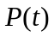, expressed as total plant biomass, is given by
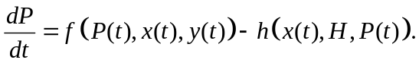
Plant growth is given by the first term, 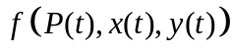. Because including or excluding nutrient dynamics can dramatically affect the ecological and evolutionary dynamics (see e.g. Loeuille et al. 2002), we compared two different plant growth functions, logistic growth or nutrient limited growth; the specifics are described in their respective sections below. The second term in Eq. (1) denotes consumption by herbivores (H). This takes the form of a Holling type 2 functional response, modified by the level of defense:
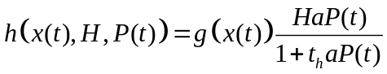
with H being herbivore biomass, and a and t_{h} the attack rate and handling time, respectively. The effect of defense on consumption is determined by 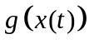, which is assumed to be a decreasing function of :
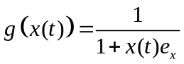
Here, 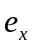 is the efficiency of defense, or the susceptibility of herbivores to the defensive trait.
We assume toxicity (y) does not directly affect consumption, and its only effect on the level of herbivory is through increasing herbivore mortality. The details are described in the following section.
Herbivore dynamics
To study the effect of an eco-evolutionary feedback between evolution of defense and herbivore population dynamics, we studied two different scenarios for all models, corresponding to specialist or generalist herbivores. Because specialists depend on the focal plant species only, their abundance directly responds to the amount of plant biomass available for their consumption. In contrast, the numerical response of generalist herbivores to plant abundance and level of defense should be much weaker, as they consume more than just the focal plant species and can switch to another food source if the focal species becomes unavailable. We assume that generalist herbivores do not respond numerically to their level of consumption of the plants considered in the model at all, allowing us to assume constant herbivore pressure.
In both scenarios, we assume that herbivores are mobile and can move easily between plants, as is the case for larger herbivores, making the herbivore and plant populations well-mixed and all interactions global.
Generalist herbivores: In this case, we assume herbivore pressure to be independent of plant abundance or the level of direct defense x. We do assume that the level of toxicity y causes increased mortality for generalist herbivores, decreasing herbivore pressure:
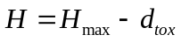
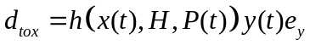
where 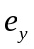 is the parameter determining how toxic any level of secondary compounds is to the herbivores. The total toxicity is determined by the product of the level of toxicity and its effectiveness, 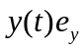, and by the amount of plant biomass consumed, under the assumption that toxic compounds are distributed evenly over the plant material susceptible to consumption.
Specialist herbivores: Here, herbivores are specialized on a plant species and depend on it; a decline in its availability, either due to reduced abundance or increased defense, will affect herbivore abundance. It is in principle possible for the plants to drive the herbivores to extinction. The herbivore dynamics are given by:
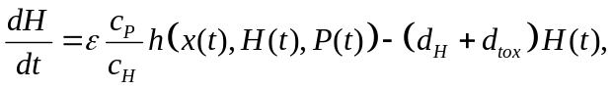
where 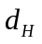and 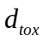 (see Eq. (5)) refer to external mortality and mortality through toxicity, respectively. ε is the conversion efficiency, the fraction of plant biomass converted into herbivore biomass. Finally, 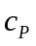 and 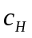 are the conversion factors between nutrients and plant and herbivore biomass, respectively; these parameters are only relevant in the nutrient competition model, but for the purpose of allowing direct comparison between the two models, we chose to use the same equation for herbivore dynamics in both models, including these parameters in the logistic growth model as well. Similarly, we assume that herbivore attack rate and handling time are the same for generalist and specialist herbivores. Although in reality specialists may be more efficient consumers, this allows us to directly compare the results of specialists and generalists.
2. Evolutionary dynamics
Adaptive dynamics
Under the adaptive dynamics framework (Geritz et al. 1998; Waxman and Gavrilets 2005), evolutionary dynamics are assumed to be slower than ecological dynamics, and the fitness of invading mutants is therefore studied assuming that the population is at its ecological equilibrium (evaluating dP/dt = 0 (eq. (1)) for generalist herbivores, and dP/dt = 0 and dH/dt = 0 (eq. (1) and (6)) in the case of specialist herbivores). The fitness of the mutant is defined as its per capita growth rate in a population of residents:
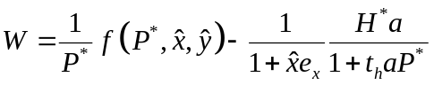
where P* and H* denote the resident population sizes at ecological equilibrium, and x and y the defense traits of the resident, and and the traits of the mutant. Because the resident growth rate at equilibrium is 0, the mutant can invade if 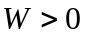. Evolutionarily singular strategies are found at the points where
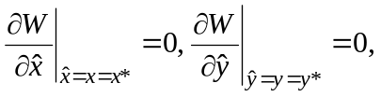
where 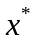 and 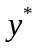 denote the evolutionarily singular strategies, which may be ESS strategies, evolutionary repellers or evolutionary branching points . For the equilibrium to be evolutionarily stable (ESS), the following condition must apply:
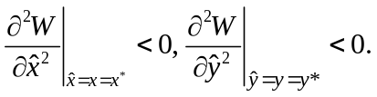
Evolutionary simulations
We used simulations to study the evolutionary dynamics and confirm the robustness of the analysis. The plant population is represented by a number of lineages (typically 200), which can be considered as individual clones in the plant population. The level of defense for each individual lineage is determined by its values for x and y, which are represented as a single genetic value. These trait values determine its growth rate and competitiveness; these in turn determine the ecological dynamics, which follow equations (1-6) above and the functions for plant growth described in the sections below, only substituting the single population P with the whole set of lineages / clones.
Evolution was simulated by the emergence and extinction of lineages (van Velzen and Etienne 2013). Each time step, each lineage has a small probability that mutation will occur (typically 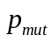 = 0.01; this probability is the same for all lineages and constant, independent of biomass). When a mutation event occurs, the lineage is split into a mother and daughter lineage. The daughter lineage inherits the trait values of the mother lineage, with some mutation in the trait(s) subject to evolution; if both traits can evolve, one of the two is chosen randomly. The new value for this trait is drawn from a normal distribution around the old value, with a small standard deviation (typically σ = 0.01). The two traits are thus assumed to evolve independently. When a daughter lineage is created, it takes the place of the lineage with the lowest biomass, which goes extinct; the total number of lineages is kept constant.
Simulations were run for 100,000 time steps, after which the average trait value for the population was recorded.

Model 1: direct trade-off
First, we look at a direct trade-off between defense and growth rate, where the intrinsic growth rate is reduced by investment into defense:
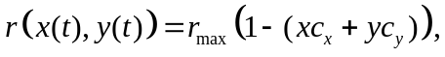
where 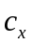 and 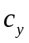 are the costliness of the two traits (allowing for the possibility that not all forms of defense are equally costly). Thus there is also implicitly a trade-off between the different defense traits: resources used for one trait are not available for another. The assumptions of all models are summarized in Table 1.
For simplicity, we will write r for 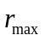 from this point onwards.

Table 1. Assumptions of each of the different trade-offs and plant growth models used.
Model | Plant growth model | Trait affected by trade-off
Model 1:  direct cost | Logistic growth (1.1) | intrinsic growth rate (r)
Model 1:  direct cost | Nutrient-limited growth (1.2) | intrinsic growth rate (r)
Model 2:  ecological cost | Lotka-Volterra competition (2.1) | intraspecific competition coefficient (α)
Model 2:  ecological cost | Nutrient competition (2.2) | nutrients available for uptake

1.1. Logistic growth
Under the logistic growth model, plant growth takes the form
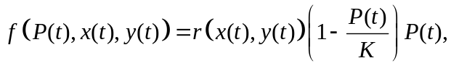
with K being the carrying capacity of the system. Using this growth function, the fitness function in eq. (7) becomes:
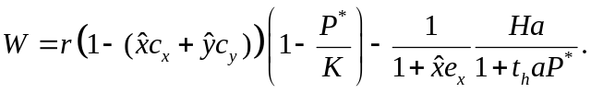
This equation enables us to derive the fitness gradients for the two traits. It becomes immediately apparent that trait y can never evolve to a nonzero (positive) ESS. Because this trait only indirectly affects consumption by reducing herbivore abundance but has no direct benefits, its fitness gradient is always negative:
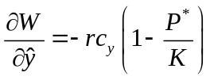
Because the mutant is rare, herbivore abundance is affected only by the resident values of these traits. This allows for evolutionary cheating: even though toxicity has the positive effect of reducing herbivore pressure, if a nonzero level of toxicity evolves, mutants with a lower investment will have all the benefits of the toxic compounds produced by the resident while carrying none of the costs. This makes 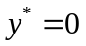 the only evolutionarily stable solution. For both generalist and specialist herbivores, simulations show that toxicity can evolve in the short run, but is eventually always replaced by a nondefending strategy; defense is not an evolutionarily stable strategy, even if the costliness of defense is very low (examples of simulation runs are shown in Figure 1A-B).
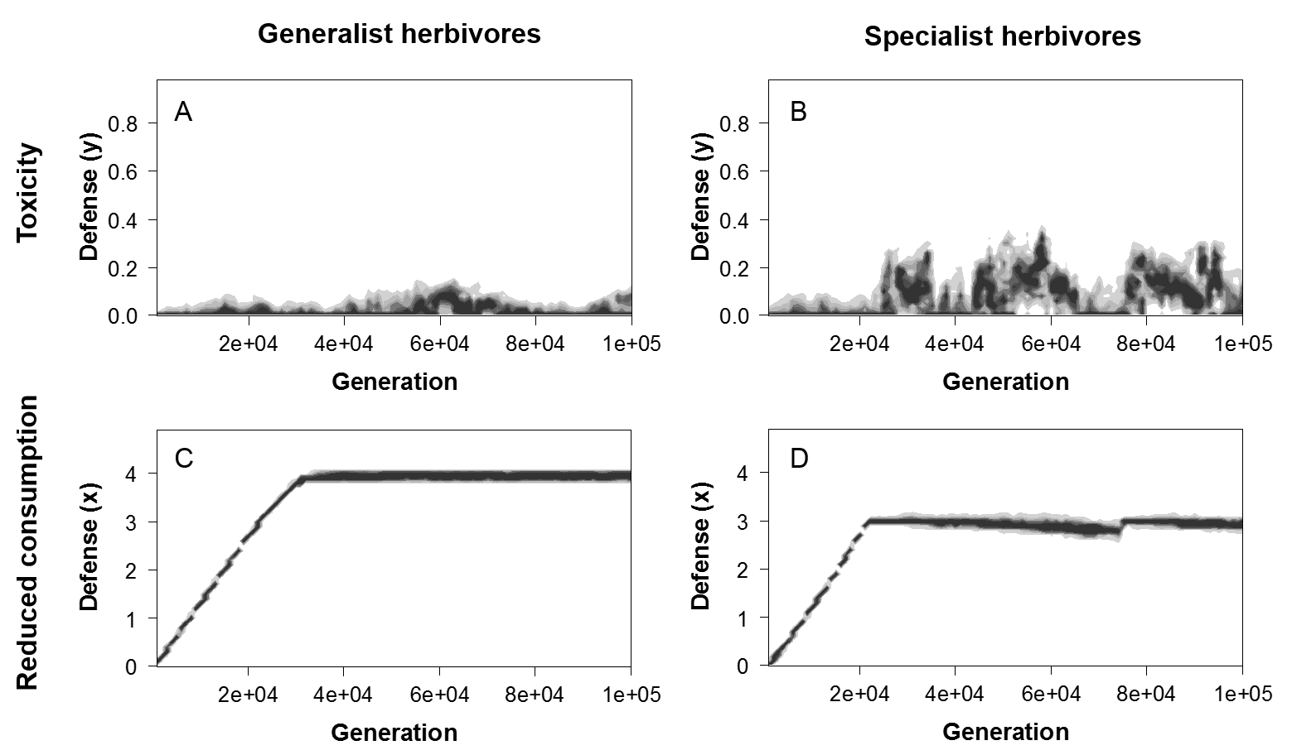
Figure 1. Simulations for the evolution of y (toxicity, A-B) and x (reduced consumption, C-D). All scenarios assume logistic growth. Simulations used 200 lineages, mutation rate = 0.01, mutation step size = 0.01; initial values for all lineages for x and y was 0. (see Evolutionary simulations for details). Other parameters: r = 0.5, a = 10⁻⁵, t_{h} = 0.1, K = 4∙10⁶. A, B: = 1.0, = 0.01; C, D: = 0.5, = 0.1. Generalist herbivores (A, C): H = 10000; Specialist herbivores (B, D): = 0.4, ε = 0.25, = 1.0, = 2.0.

The fitness gradient for has an additional positive term which allows a nonzero ESS:
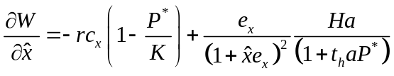
1.1.1. Generalist herbivores (constant)
Substituting the ecological equilibrium for P* (obtained by setting Eq. (1) to 0) and 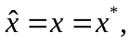in Eq. (14), we get one ESS solution:
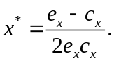
The ESS defense depends only on two parameters, the efficiency of defense 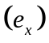 and the costliness 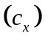. There is a nonzero investment into defense if 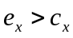, and the ESS investment increases monotonically with to an asymptotic value of 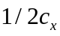, if defense is infinitely efficient or costs are infinitely low. Alternatively, it makes sense to express the ESS investment as the fraction of total resources allocated to defense. Multiplying the ESS defense with the cost , we get an ESS investment of
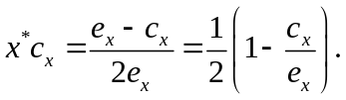
As shown in Figure 2A, this increases monotonically with to a maximum value of ½.
1.1.2. Specialist herbivores (dynamic)
The same fitness function and fitness gradients as in the generalist herbivore case apply; the only difference is that H is no longer a constant. Substituting H = H* (obtained by setting Eq (6) to 0) in eq. (14), we now find two singular strategies:
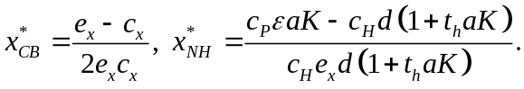
The first is the same cost-benefit equilibrium as with constant herbivore pressure (CB); the second is the level of defense that reduces the herbivore population to zero (no herbivores, NH), so that H* = 0, meaning (from eq. (14)) that P* = K; this expression can be derived by solving dH/dt = 0 (eq. (6)) and substituting P* = K.
As Figure 2B shows, at the lower range for (low effectiveness of defense compared to the cost) the CB equilibrium is lower than the NH equilibrium, and vice versa for the higher range of .
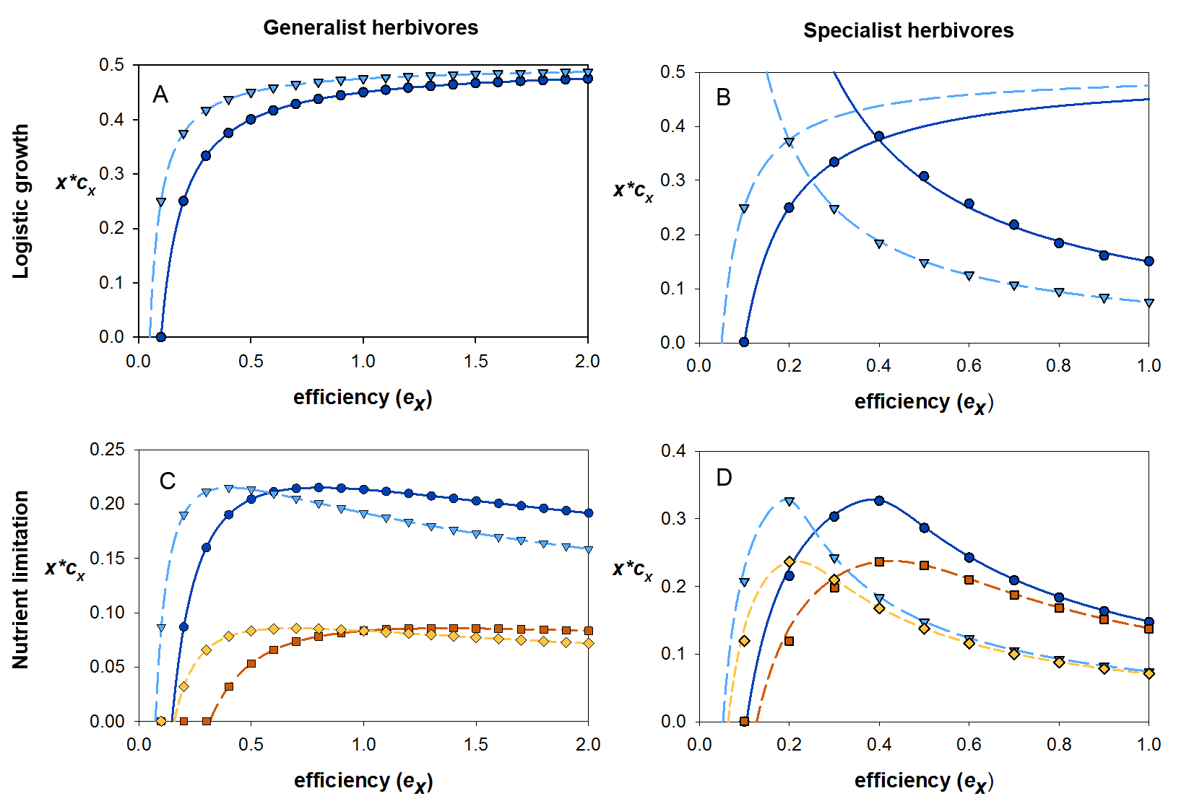
Figure 2. Analytical predictions (lines) and simulation results (symbols) for the evolutionarily stable level of defense, expressed as the fraction of resources invested into defense (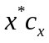). Symbols represent averages of 20 replicate simulations, recorded after 100,000 generations; number of lineages = 200, p_{mut =} 0.01, σ = 0.01. (A, B): logistic growth; solid line, circles: 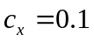; dashed line, triangles: 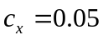. (C, D): nutrient limited growth; solid line, circles: , d_{p} = 0.01; long dash, triangles: , d_{p} = 0.01; medium dash, squares: , d_{p} = 0.05; short dash, diamonds: , d_{p} = 0.05. Generalist herbivores (A, C): H = 10000. Specialist herbivores (B, D): = 0.4, ε = 0.25, = 1.0, = 2.0. In all, r = 0.5, a = 10⁻⁵, t_{h} = 0.1, T = K = k = 4∙10⁶.

Evolutionary stability
For evolutionary stability, Eq. (9) must apply. Taking the second derivative of the fitness function with respect to :
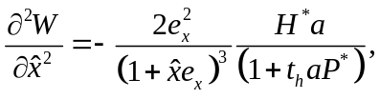
Looking at the first equilibrium (CB), we substitute 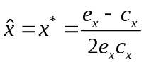 in (18), which leaves us with
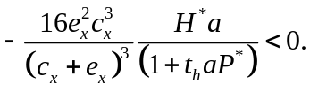
Assuming all parameters and P* are positive, it depends on the value for H* whether this condition holds. In the model with generalist herbivores, H* is always positive. The second derivative is thus negative, and the CB equilibrium is thus always stable (see Figure 1C).
For specialist herbivores, the CB ESS is again stable if 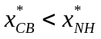 so that H* > 0, but is unstable if 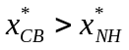 (H* < 0). x thus always evolves to whichever of the two equilibria has the lowest value. The simulations confirm this (Figure 2B). In the NH equilibrium, H* = 0; this means the second derivative is always zero, making the equilibrium neutrally stable, meaning that once defense has evolved to this point, all strategies including the ESS strategy have the same fitness and random drift may occur. However, the simulations show this does not happen (Figure 1D): as soon as the herbivores reach a very low abundance, there is selection against defense (though it is weak), gradually lowering the average defense in the population. With defense decreasing to slightly lower than the NH equilibrium, the herbivores can re-establish, causing a rapid evolution towards the NH equilibrium again, after which the cycle repeats.
1.2 Nutrient limited growth
The second model for plant growth, nutrient limitation, takes the following form when assuming a direct trade-off between defense and growth rate (modified from (van Velzen and Etienne 2013):
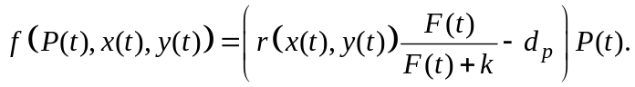
In this model plant growth is limited by the amount of nutrients available in the system, following Michaelis-Menten dynamics, where k is the half-saturation constant and F(t) the amount of nutrients available for uptake. F(t) is defined as all nutrients not bound up in plant or animal biomass: 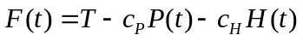, where and refer to the conversion factors between nutrients and plant and herbivore biomass, respectively. T is the total amount of nutrients in the system, similar to K in logistic growth, and d_{p} is the rate of natural death for plants.
The fitness function for the nutrient limitation model takes the following form:
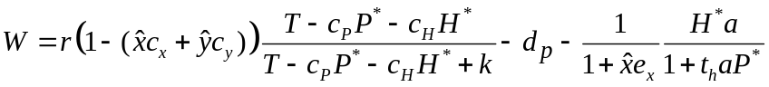
Closed-form solutions of the ESS values can be obtained, but they are not informative except in the extreme case of d_{p} = 0. In this case, the equilibria and their stability are exactly the same as in the logistic growth model. For d_{p} > 0, the ESS values for eq. (21) were calculated numerically and are described below; there is always only one single positive ESS value.
1.2.1. Generalist herbivores
The main difference between the logistic growth and nutrient limitation models is that in the model with nutrient limited growth, is no longer a monotonically increasing function of (Figure 2C); instead, if the efficiency of defense is very high, the ESS investment drops off again, eventually towards zero if defense is infinitely efficient. The highest investment thus occurs for an intermediate efficiency. While increases more rapidly with if the costliness of defense is lower, again the maximum value for the total investment does not depend on . Numerical analysis and simulations confirm the equilibria are evolutionarily stable (Figure 2C).
In contrast with the logistic growth model and the nutrient model with d_{p} = 0, parameters other than the costliness and effectiveness of defense also affect the ESS investment, most notably the plants’ natural mortality rate d_{p}: higher mortality leads to less defense (Figure 2C). Nutrient availability also plays an important role: in nutrient-rich systems (high T) investment into defense is less than in nutrient-poor systems. Because higher nutrient availability leads to a higher standing biomass, proportionally less biomass is lost through herbivory, leading to a lower optimal investment. The effects of intrinsic growth rate and resource uptake rate are the same, though much less strongly (Supplementary Material, Appendix A, Figure A1). Lastly, the ESS investment increases with herbivore pressure (H) (Supplementary Material, Appendix A, Figure A2)
1.2.2 Specialist herbivores
ESS investment follows the same general shape as in the logistic growth model, but decreases with plant death rate; only when d_{p} = 0 can the investment evolve to high enough levels that herbivore abundance reaches zero (the NH equilibrium in eq. (17)). Numerical calculations and simulations confirm that the equilibria are evolutionarily stable (Figure 2D).
Again, nutrient availability has a strong effect on the level of defense that evolves; but in contrast with the model for generalist herbivores, higher nutrient availability (higher T) leads to a higher investment into defense (Figure 3B), and the same effect is seen for the other parameters affecting plant growth (intrinsic growth rate r and the half-saturation constant k; Supplementary Material, Figure A1). The explanation for this difference lies in the feedback between plants and herbivore abundance: the higher plant biomass found in resource-rich habitats causes an increase in herbivore abundance, in turn leading to a higher optimal investment into defense.
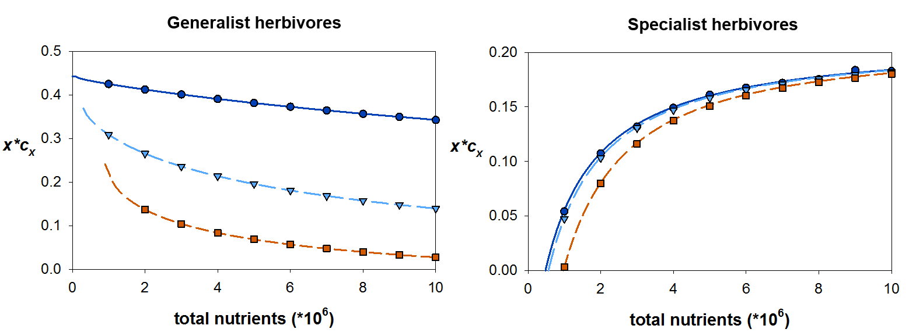
Figure 3. Analytical predictions (lines) and simulation results (symbols) for the optimal defense trait value depending on the total amount of nutrients in the system T. Symbols represent averages of 20 replicate simulations, recorded after 100,000 generations; number of lineages = 200, p_{mut =} 0.01, σ = 0.01. Solid line, circles: d_{p} = 0.001; long dash, triangles: d_{p} = 0.01; medium dash, squares: d_{p} = 0.05. Generalist herbivores (left): H = 10000. Specialist herbivores (right): = 0.4, ε = 0.25, = 1.0, = 2.0. In both, r = 0.5, a = 10⁻⁵, t_{h} = 0.1, k = 4∙10⁶, = 1.0, = 0.1.

Model 2: ecological trade-off
2.1 Logistic growth
As an ecological cost, we assume that defense comes with a cost in competitiveness rather than growth rate. This means that growth rate is not affected when a plant is by itself, and the cost is only expressed under competition (see e.g. Kempel et al. 2011). In the logistic growth model, we assume Lotka-Volterra competition where defense negatively affects the competition coefficient:
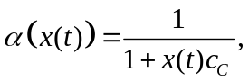
so that investing in defense gives surrounding plants a competitive advantage; for example, if slower growth gives a disadvantage in light competition.
Because adaptive dynamics assumes the mutant biomass is zero, it is not well suited for a model with a trade-off directly affecting competitiveness, as the mutant’s competitive effect on the resident will be zero (and thus there will be no costs for the mutant, making 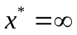 the only ESS). We adapted the equations to incorporate a nonzero mutant biomass (details of the derivation of this model can be found in Supplementary Material, Appendix B) and used Lotka-Volterra competition in the simulations. Here we assume that all intra-lineage competition coefficients remain 1, and the inter-lineage competition coefficient is described by eq. (22) above. Because the carrying capacity of the system will increase with lower competition coefficients, we normalized competition so that 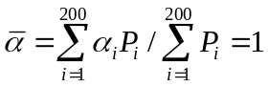 (see Appendix B).
2.1.1 Generalist herbivores
If costs are low (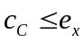), there is one stable ESS when herbivores are generalist (Figure 4A, 5A). However, if 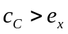, the equilibrium value for is no longer evolutionarily stable; instead it is an evolutionary branching point. From here, divergent evolution takes place, leading eventually to one plant population with no defense, and one with a high level of defense. If there are no costs other than in competitiveness, defense evolves indefinitely to higher values in the latter population (Figure 5B). If there additional direct costs affecting growth rate as well as competitive ability, it eventually reaches a stable level of investment (Figure 5C). If direct costs are high enough that the ESS investment based on that is lower than the evolutionary branching point, no branching occurs and the population reaches a stable ESS (Figure 5D).
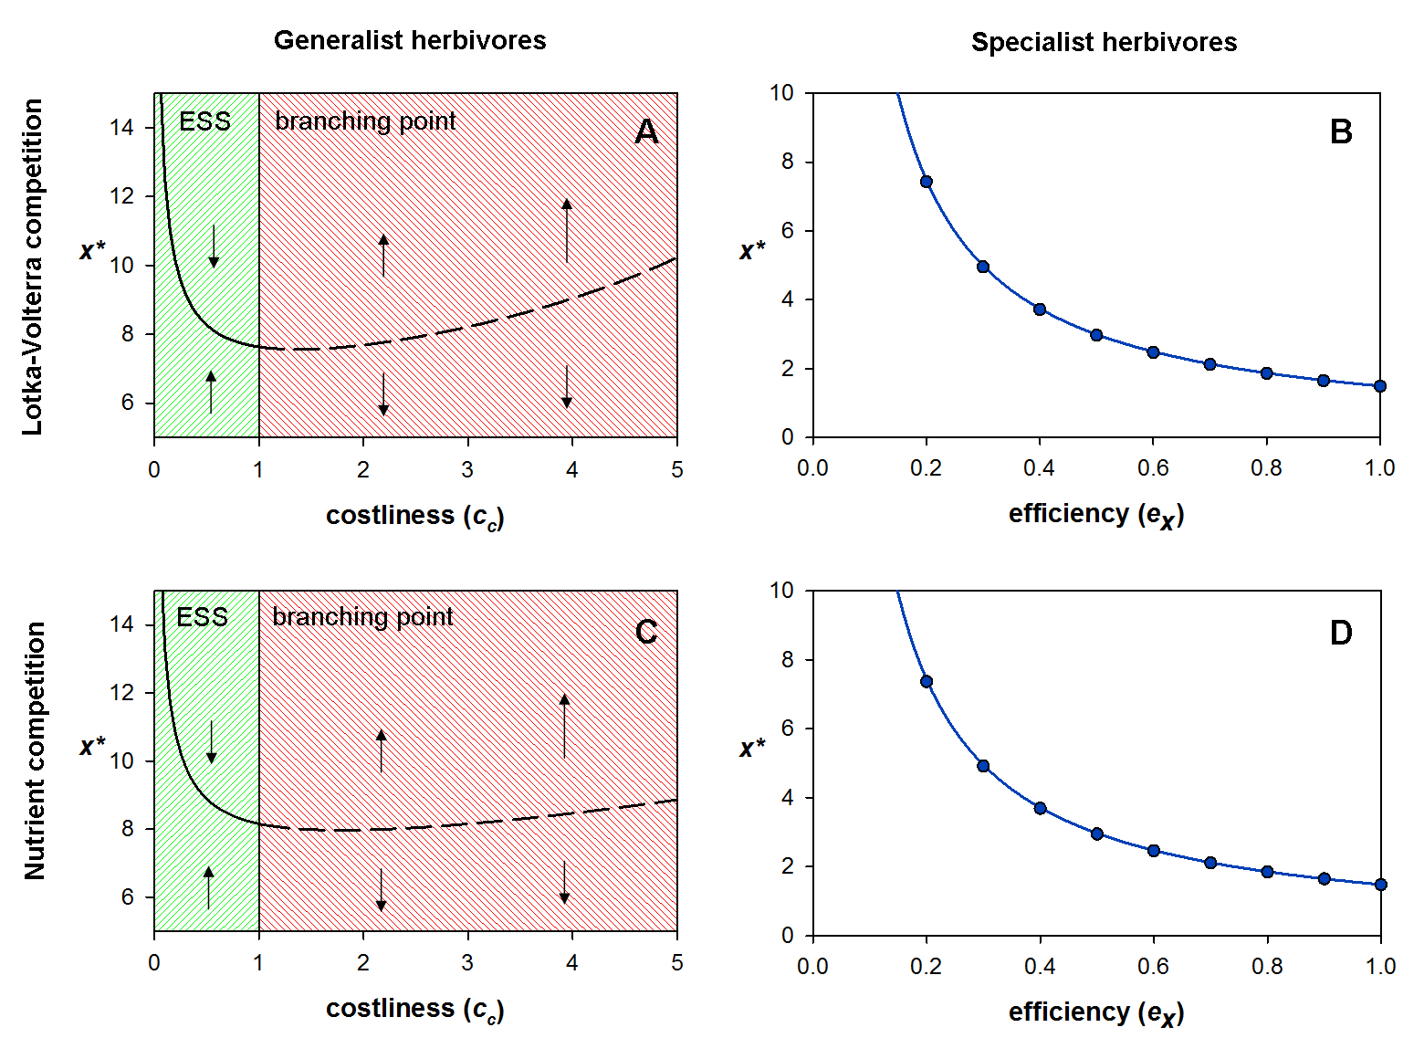
Figure 4. Numerical predictions simulation results of the Lotka-Volterra competition model (A, B) and the nutrient competition model (C, D). In all graphs 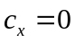, and mutant biomass = 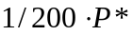, analogous to 1 out of 200 lineages in the simulation (see Supplementary Material, Appendix B). All other parameters the same as in Figure 2, unless otherwise specified. Generalist herbivores (A, C): 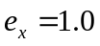. Solid line: stable ESS; dashed line: branching point. Specialist herbivores (B, D): 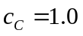. Lines: numerical predictions; symbols: simulation results, average of 10 simulation runs, recorded after 100,000 generations.

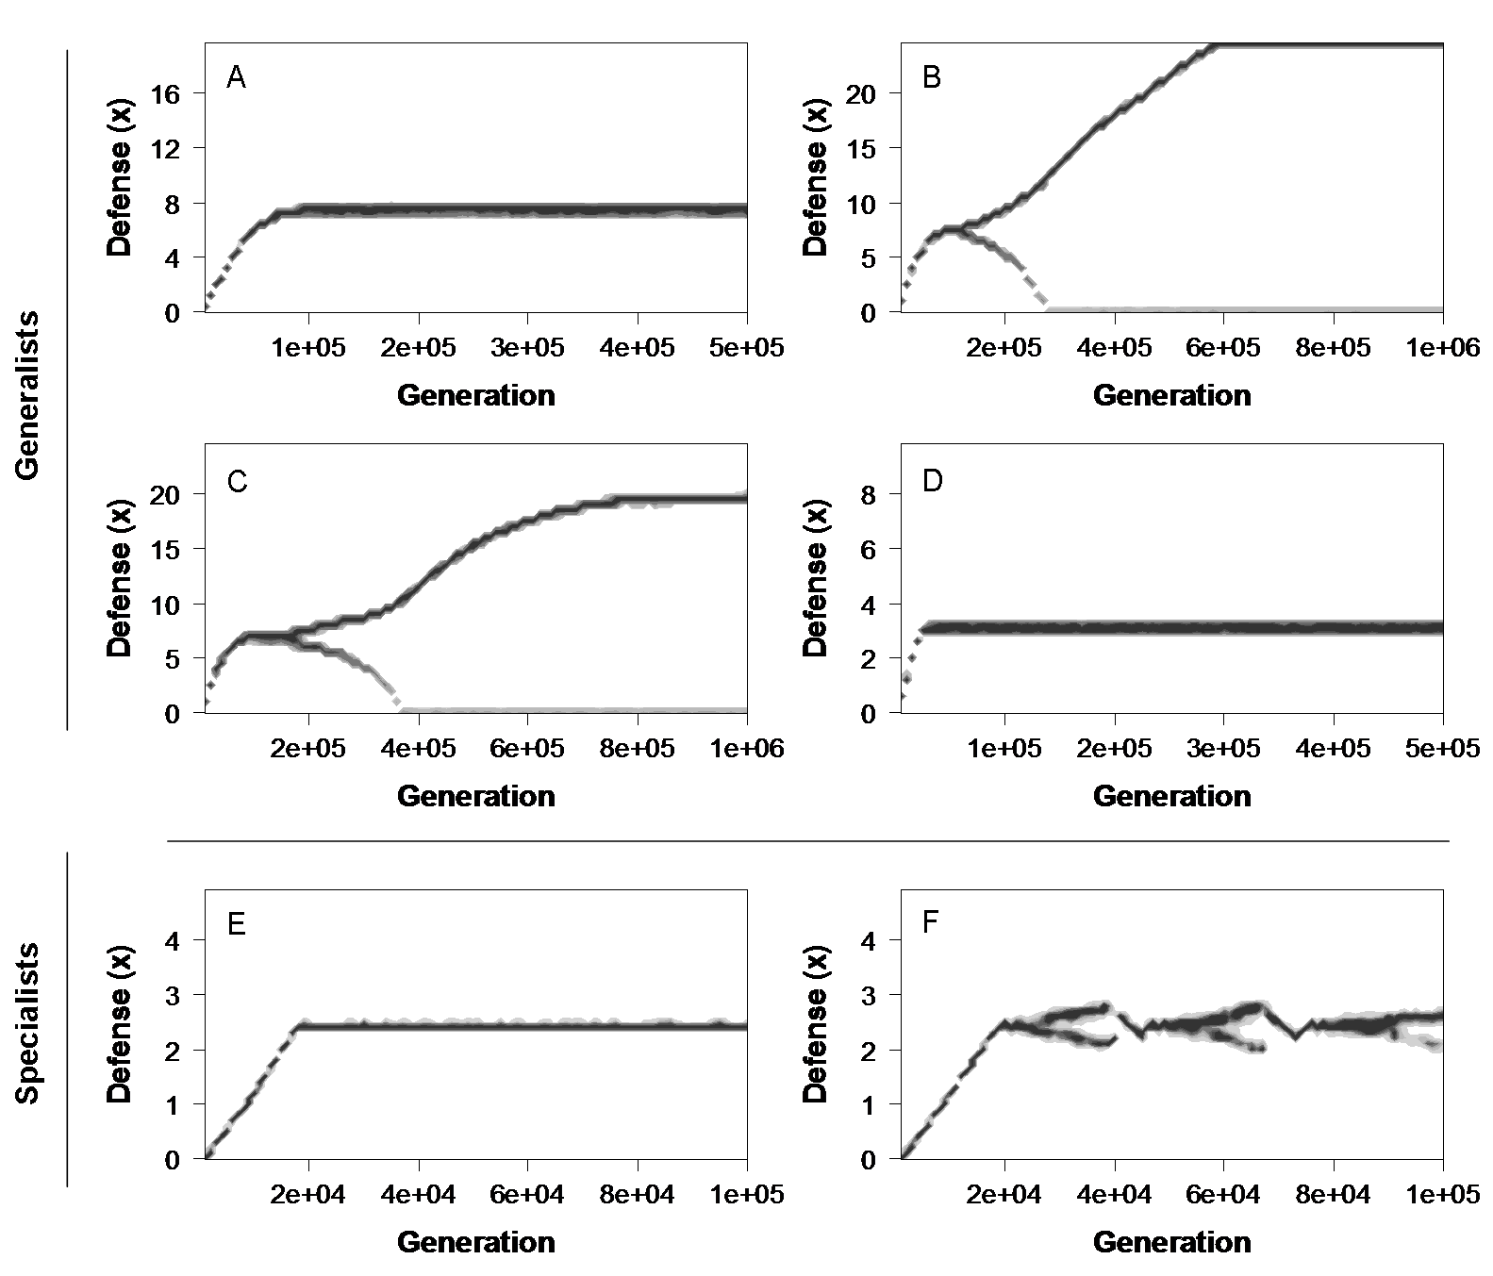
Figure 5. Simulations of the Lotka-Volterra competition model with generalist herbivores (A-D) or specialist herbivores (E-F). Number of lineages = 200, mutation rate = 0.01, mutation step size = 0.01; all other parameters the same as in Figure 2, unless otherwise specified. (A) , 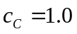, ; (B) , 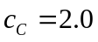, ; (C) , , 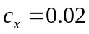; (D) , , 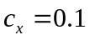; (E) 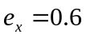, 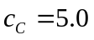, ; (F) , 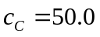, .
2.1.2 Specialist herbivores
In the case of specialist herbivores the ESS investment is always nonzero, no matter how high the costliness, unlike for the direct trade-off with growth. When 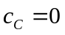, the ESS investment is the amount required to drive the herbivores extinct; when 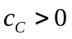, the ESS investment is always lower than this, though the difference is only marginal (, : 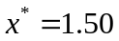; : 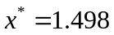; : 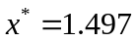, all other parameters the same as in Figure 2B). Thus, herbivores are always present after the ESS has been reached, though generally in low abundance. However, evolutionary branching does not get off the ground, unless the cost of defense is very high (Figure 5E, F), and branching never leads to stable coexistence of defended and undefended plants. Though initially branching may occur, especially when the efficiency of defense is low, the feedback between ecological and evolutionary dynamics prevents stable coexistence of two defense strategies. As plants with a lower investment in defense evolve, total consumption by herbivores increases, leading to higher herbivore abundance. The increase in herbivore pressure drives the less-defending population extinct, after which the more-defending population returns to the ESS value (Figure 5F). Thus, in contrast to the model with generalist herbivores, stable branching and coexistence of different trait values never occurs with specialist herbivores. Increasing the mutational step size or starting the simulation with a diversified plant population does not change this: the presence of a less-defended plant invariably causes a rise in herbivore pressure, driving the less-defended plant extinct.
2.2 Nutrient competition
We modified the nutrient limitation model into a model for nutrient competition, including a cost in competitiveness rather than growth rate. In this case, we assume that investment into defense reduces the ability to monopolize nutrients, so that competitors with lower defense get a disproportionally larger share. Thus, the amount of nutrients that is available to a plant 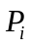 depends, apart from total plant and herbivore biomass, on its own level of defense as well as that of its competitors:
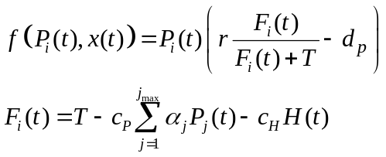
The competitiveness 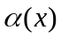 is again given by the decreasing function of given in Eq. (22), and the values are again normalized so that 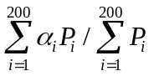.
2.2.1 Generalist herbivores
The results for generalist herbivores mirror the results of the Lotka-Volterra model (compare Figure 4C with Figure 4A). Low cost () again gives rise to a stable ESS, but when the equilibrium is an evolutionary branching point. From here, the defense trait diverges into a defending and a non-defending strategy.
2.2.2 Specialist herbivores
As in the Lotka-Volterra model, ESS investment for specialist herbivores decreases with efficiency , and again only marginally decreases with 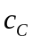 (Figure 4D). Evolutionary dynamics around the ESS are the same as in the Lotka-Volterra model: while initially branching may occur, stable coexistence is not possible.

Discussion
Our results show that the type of trade-off (direct vs. ecological) between herbivore defense and other plant traits can have a dramatic effect on the course of evolution. In addition, generalist herbivores can cause very different evolutionary dynamics in plants than specialists.
Direct and ecological trade-offs
Growth rate and competitive ability are often used interchangeably when it comes to trade-offs between defense and competition, but the distinction between the two is not trivial. While a plant’s growth rate is obviously a major factor determining its ability to compete with other plants, there is a major difference between a trade-off affecting competitive ability through growth rate and a trade-off directly affecting competitive ability itself. While many models exist that study the evolution of defense when defense is costly, ranging from relatively simple models (Coley et al. 1985; Fagerstrom et al. 1987; Yamamura and Tsuji 1995; Poitrineau et al. 2004; Ito and Sakai 2009) to community or metacommunity models (Loeuille et al. 2002; Loeuille and Loreau 2004; Loeuille and Leibold 2008; Vage et al. 2014), all these models use a trade-off with growth rate or resource uptake rate. To our knowledge, our model is the first to look at a trade-off affecting competitive ability itself, and our results show that this has a major impact on the resulting evolutionary dynamics.
Direct effects always lead to one optimal strategy against herbivores. In addition we found, as did Loeuille et al (2002), that including nutrient dynamics had several major effects on the evolutionary dynamics, especially when defense is against generalist herbivores. In a logistic growth model with direct costs the ESS investment always increases with increased efficiency of defense, and solely depends on the cost and efficiency of defense. In contrast, in the nutrient limitation model, the highest investment occurs for intermediate efficiency; moreover, ESS investment depends strongly on other parameters determining plant growth, especially nutrient availability (see The resource availability hypothesis below). While throughout the manuscript we have assumed a direct trade-off to be between defense and the intrinsic growth rate r, this is not the only direct trade-off possible in the nutrient limitation model. Assuming instead that the trade-off affects nutrient uptake rate (where higher defense increases the half-saturation constant k) or natural mortality (increasing d_{p}) does not significantly change the results (Supplementary Material, Appendix A, Figure A3). In all cases, a single ESS is found, with the highest investment occurring for intermediate efficiency.
However, when the trade-off affects competitive ability (intraspecific competition or ability to utilize shared nutrients), high costs can lead to evolutionary branching and stable coexistence of non-defending and defending plants. Like Weis & Hochberg (2000), we find that allowing for the possibility of asymmetric competition (through a trade-off with competitiveness) leads to dramatically different predictions on optimal defense. Unlike their study, however, we also looked at the effects of a trade-off between defense and competitiveness, and our results indicate that this can lead to divergent evolution and the coexistence of different strategies. Therefore, it is possible for plants to have no defense against herbivory, even if faced with conditions where defense would seem an optimal strategy.
Other mechanisms have been found to lead to stable coexistence of different defense strategies; examples include selective grazing by herbivores, combined with a higher nutrient content of preferred plants (Branco et al. 2010), dispersal and metacommunity dynamics (Loeuille and Leibold 2008) and the existence of a nonlinear (concave) trade-off between growth and defense (Vage et al. 2014). While we assume a linear trade-off between defense and growth in Model 1, relaxing this assumption does not change our main result that there is only one stable ESS (Supplementary Material, Appendix A, Figure A4). Our model adds a new mechanism for evolutionary divergence and coexistence, finding both are possible in a relatively simple ecological model. However, this result only applies to generalist herbivores; with specialist herbivores, although different strategies may evolve to some extent, it is never possible for them to stably coexist. This is because of the feedback between plant defense and herbivore population dynamics: when a non-defending plant arises, whether through gradual evolution or immigration, the increased food availability increases herbivore abundance, to which the non-defending plants is defenseless. Not only are assumptions regarding which traits are affected by the trade-off critical for predicting the outcome of evolution, so are the assumptions on how the herbivores respond to the evolution of defense.
Direct and indirect effects of defense
We find that herbivore defense can only evolve if it has a direct effect on the consumption rate. Defense working indirectly through affecting herbivore pressure, such as the presence of toxic compounds in consumed plant material, does not evolve. A population producing toxic defense compounds is open to evolutionary cheating: a mutant with a lower investment into defense has a negative effect on itself (through increased herbivore pressure), but equally on its competitors, yielding no overall negative fitness effects; but it does give the advantage of economizing on defense. If toxicity confers any cost at all, even a very low cost, this strategy always has a higher fitness, and in none of our scenarios could pure toxicity evolve. The same reasoning applies to other forms of defense that work only through indirect means, such as compounds that lower digestibility of consumed plant material: these would not evolve either. A positive direct effect on the mutant is necessary for defense to evolve.
Both toxicity and low quality can evolve as defense, if they also directly reduce consumption of the defending plant. We assume that the effect of toxicity is always indirect, as herbivores in our model are mobile and can move freely through the plant population; this is not always the case in nature, where small arthropod herbivores spend their entire lifespan on the same plants, allowing toxicity to affect consumption through reducing the local herbivore population affecting it (but not the surrounding competing plants). This scenario is more akin to a direct positive fitness effect and may allow pure toxicity to evolve.
A similar argument can be made for low digestibility. Lower quality food can reduce herbivore growth rate and increase their mortality (Häggström and Larsson 1995; Benrey and Denno 1997; Coley et al. 2006), but this only has an effect on plant evolution if low quality food also reduces consumption rate, for example because it takes longer to pass through the digestive system (Clissold et al. 2009). Another way that toxicity or low quality can directly reduce damage is if herbivores learn to recognize and avoid them. Intuitively, this appears most likely with generalist herbivores, which have the option of easily switching to other plant species.
The resource availability hypothesis
The resource availability hypothesis states that slow-growing plants in resource-poor environments should invest more into defense than fast-growing plants in resource-rich environments (Coley et al. 1985; de Jong 1995). While it has been argued that this is not necessarily the case if the plants affect the amount of resources available (Loreau and de Mazancourt 1999), it has empirically been confirmed (Endara and Coley 2011).
In our model, we found two opposite predictions for the effect of nutrients and intrinsic growth rate, driven by the fact that faster-growing plants have a higher standing biomass. If herbivores do not respond numerically to plant biomass (the generalist scenario), this means that the plants’ per capita loss to herbivory is lower. Consumption does increase with plant biomass, but not proportionately, leading to a lower optimal level of defense. By contrast, if herbivores become more abundant when they have more food available (the specialist scenario), faster-growing plants should invest more into defense.
External or natural mortality rate correlated negatively with optimal defense across all scenarios. This can be understood as follows: if plant material can be lost either through natural mortality or through herbivory, higher natural mortality decreases the probability that the loss will occur through herbivory, making defense less optimal even if the total loss through herbivory is the same. This contradicts the RAH, which states that slow-growing plants should defend more because lost biomass is more difficult to replace. Because slow-growing plants tend to have slower turnover, the effects of faster growth and higher mortality may be difficult to disentangle, but our result dovetails nicely with studies showing that defense is reduced in ageing leaves (van Dam et al. 1994; Iwasa et al. 1996; van Dam et al. 1996).
Future directions
Our model does not allow for inducible defense, instead assuming that all defense is constitutive. If defense is costly or herbivore pressure is low, inducible defense may confer a fitness advantage over constitutive defense, because defenses only have to be mobilized when needed, reducing costs of defense (Poitrineau et al. 2004; Tiffin et al. 2006; Ito and Sakai 2009). Moreover, inducible and constitutive defenses have different effects on herbivore population dynamics (Underwood and Rausher 2002): constitutive defense has a stronger negative effect on herbivore abundance than inducible defense, which may again affect optimal defense.
Furthermore, we divided the scenarios between generalist and specialist herbivores, assuming plant suffer only one of the two, while in nature they would likely face both. Generalist and specialist herbivores may exert very different selection pressures (Lankau 2007): defenses that work against generalists are ineffective against specialists that have co-evolved with the plant, and the same trait that confers resistance against generalist herbivores can increase susceptibility to specialists. This may allow for polymorphism in defense (Agrawal et al. 1999), and generate more complicated evolutionary dynamics.
Lastly, throughout our study we assume herbivores easily move from plant to plant; this assumption likely affects some of our conclusions (especially our results on direct vs. indirect effects). A model structure allowing for localized effects may give different results: in particular, it may allow for toxicity to evolve where in our model it does not. It is unclear whether it would change the overall conclusions that direct (growth) costs always give rise to one stable ESS but a competitiveness cost can lead to coexistence; the metacommunity model by Loeuille & Leibold (2008) would suggest that divergent strategies can evolve under direct costs as well. We believe this would be the most interesting avenue for further research.
In conclusion, ecological costs and the role of ecological interactions in the evolution of herbivore defense have been largely ignored in theoretical studies so far. Our results suggest that competitive effects can have a dramatic effect on the course of evolution.

References
Adler, L. S. 2000. The ecological significance of toxic nectar. Oikos 91:409-420.
Agrawal, A. A. 2004. Plant defense and density dependence in the population growth of herbivores. American Naturalist 164:113-120.
Agrawal, A. A., P. M. Gorski, and D. W. Tallamy. 1999. Polymorphism in plant defense against herbivory: constitutive and induced resistance in Cucumis sativus. Journal of chemical ecology 25:2285-2304.
Benrey, B., and R. F. Denno. 1997. The slow-growth-high-mortality hypothesis: a test using the cabbage butterfly. Ecology 78:987-999.
Bergelson, J., and C. B. Purrington. 1996. Surveying patterns in the cost of resistance in plants. American Naturalist 148:536-558.
Branco, P., M. Stomp, M. Egas, and J. Huisman. 2010. Evolution of nutrient uptake reveals a trade-off in the ecological stoichiometry of plant-herbivore interactions. American Naturalist 176:E162-E176.
Clissold, F. J., G. D. Sanson, J. Read, and S. J. Simpson. 2009. Gross vs. net income: how plant toughness affects performance of an insect herbivore. Ecology 90:3393-3405.
Coley, P. D. 1987. Interspecific variation in plant anti-herbivore properties: the role of habitat quality and rate of disturbance. New Phytologist 106:251-263.
Coley, P. D., M. L. Bateman, and T. A. Kursar. 2006. The effects of plant quality on caterpillar growth and defense against natural enemies. Oikos 115:219-228.
Coley, P. D., J. P. Bryant, and F. S. Chapin. 1985. Resource availability and plant antiherbivore defense. Science 230:895-899.
de Jong, T. J. 1995. Why fast-growing plants do not bother about defence. Oikos 74:545-548.
DeAngelis, D. L., S. Ju, R. Liu, J. P. Bryant, and S. A. Gourley. 2012. Plant allocation of carbon to defense as a function of herbivory, light and nutrient availability. Theoretical Ecology 5:445-456.
Endara, M., and P. D. Coley. 2011. The resource availability hypothesis revisited: a meta-analysis. Functional Ecology 25:389-398.
Fagerstrom, T., S. Larsson, and O. Tenow. 1987. On optimal defence in plants. Functional Ecology 1:73-81.
Felton, G. W., K. L. Korth, J. L. Bi, S. V. Wesley, D. V. Huhman, M. C. Mathews, J. B. Murphy, C. Lamb, and R. A. Dixon. 1999. Inverse relationship between systemic resistance of plants to microorganisms and to insect herbivory. Current Biology 9:317-320.

Gehring, J. L., and L. F. Delph. 1999. Fine-scale genetic structure and clinal variation in Silene acaulis despite high gene flow. Heredity 82:628-637.
Geritz, S. A. H., E. Kisdi, G. Meszena, and J. A. J. Metz. 1998. Evolutionarily singular strategies and the adaptive growth and branching of the evolutionary tree. Evolutionary Ecology 12:35-57.
Häggström, H., and S. Larsson. 1995. Slow larval growth on a suboptimal willow results in high predation mortality in the leaf beetle Galerucella lineola. Oecologia 104:308-315.
Herms, D. A., and W. J. Mattson. 1992. The dilemma of plants: to grow or defend. Quarterly Review of Biology 67:283-335.
Ito, K., and S. Sakai. 2009. Optimal defense strategy against herbivory in plants: conditions selecting for induced defense, constitutive defense, and no-defense. Journal of theoretical biology 260:453-459.
Iwasa, Y., T. Kubo, N. van Dam, and T. J. De Jong. 1996. Optimal level of chemical defense decreasing with leaf age. Theoretical population biology 50:124-148.
Kempel, A., M. Schaedler, T. Chrobock, M. Fischer, and M. van Kleunen. 2011. Tradeoffs associated with constitutive and induced plant resistance against herbivory. Proceedings of the National Academy of Sciences of the United States of America 108:5685-5689.
Krzysztof Janczur, M. 2009. Optimal energy allocation to growth, reproduction, and production of defensive substances in plants: a model. Evolutionary Ecology Research 11:447-470.
Lankau, R. A. 2007. Specialist and generalist herbivores exert opposing selection on a chemical defense. New Phytologist 175:176-184.
Loeuille, N., and M. A. Leibold. 2008. Ecological consequences of evolution in plant defenses in a metacommunity. Theoretical population biology 74:34-45.
Loeuille, N., and M. Loreau. 2004. Nutrient enrichment and food chains: can evolution buffer top-down control? Theoretical population biology 65:285-298.
Loeuille, N., M. Loreau, and R. Ferriere. 2002. Consequences of plant-herbivore coevolution on the dynamics and functioning of ecosystems. Journal of theoretical biology 217:369-381.
Loreau, M., and C. de Mazancourt. 1999. Should plants in resource-poor environments invest more in antiherbivore defence? Oikos 87:195-200.
Poitrineau, K., S. P. Brown, and M. E. Hochberg. 2004. The joint evolution of defence and inducibility against natural enemies. Journal of theoretical biology 231:389-396.
Strauss, S. Y., J. A. Rudgers, J. A. Lau, and R. E. Irwin. 2002. Direct and ecological costs of resistance to herbivory. Trends in Ecology & Evolution 17:278-285.
Strauss, S. Y., D. H. Siemens, M. B. Decher, and T. Mitchell-Olds. 1999. Ecological costs of plant resistance to herbivores in the currency of pollination. Evolution 53:1105-1113.
Tiffin, P., B. D. Inouye, and N. Underwood. 2006. Induction and herbivore mobility affect the evolutionary escalation of plant defence. Evolutionary Ecology Research 8:265-277.
Underwood, N. 1999. The influence of plant and herbivore characteristics on the interaction between induced resistance and herbivore population dynamics. American Naturalist 153:282-294.
Underwood, N., and M. Rausher. 2002. Comparing the consequences of induced and constitutive plant resistance for herbivore population dynamics. American Naturalist 160:20-30.
Vage, S., J. E. Storesund, J. Giske, and T. F. Thingstad. 2014. Optimal defense strategies in an idealized microbial food web under trade-off between competition and defense. Plos One 9:e101415.
van Dam, N. M., and I. T. Baldwin. 1998. Costs of jasmonate-induced responses in plants competing for limited resources. Ecology Letters 1:30-33.
van Dam, N. M., T. J. de Jong, Y. Iwasa, and T. Kubo. 1996. Optimal distribution of defences: Are plants smart investors? Functional Ecology 10:128-136.
van Dam, N. M., R. Verpoorte, and E. van der Meijden. 1994. Extreme differences in pyrrolizidine alkaloid levels between leaves of Cynoglossum officinale. Phytochemistry 37:1013-1016.
van Velzen, E., and R. S. Etienne. 2013. The evolution and coexistence of generalist and specialist herbivores under between-plant competition. Theoretical Ecology 6:87-98.
Waxman, D., and S. Gavrilets. 2005. 20 Questions on Adaptive Dynamics. Journal of Evolutionary Biology 18:1139-1154.
Weis, A. E., and M. E. Hochberg. 2000. The diverse effects of intraspecific competition on the selective advantage to resistance: A model and its predictions. American Naturalist 156:276-292.
Yamamura, N., and N. Tsuji. 1995. Optimal strategy of plant antiherbivore defense: implications for apparency and resource-availability theories. Ecological Research 10:19-30.

Appendix A: supporting figures

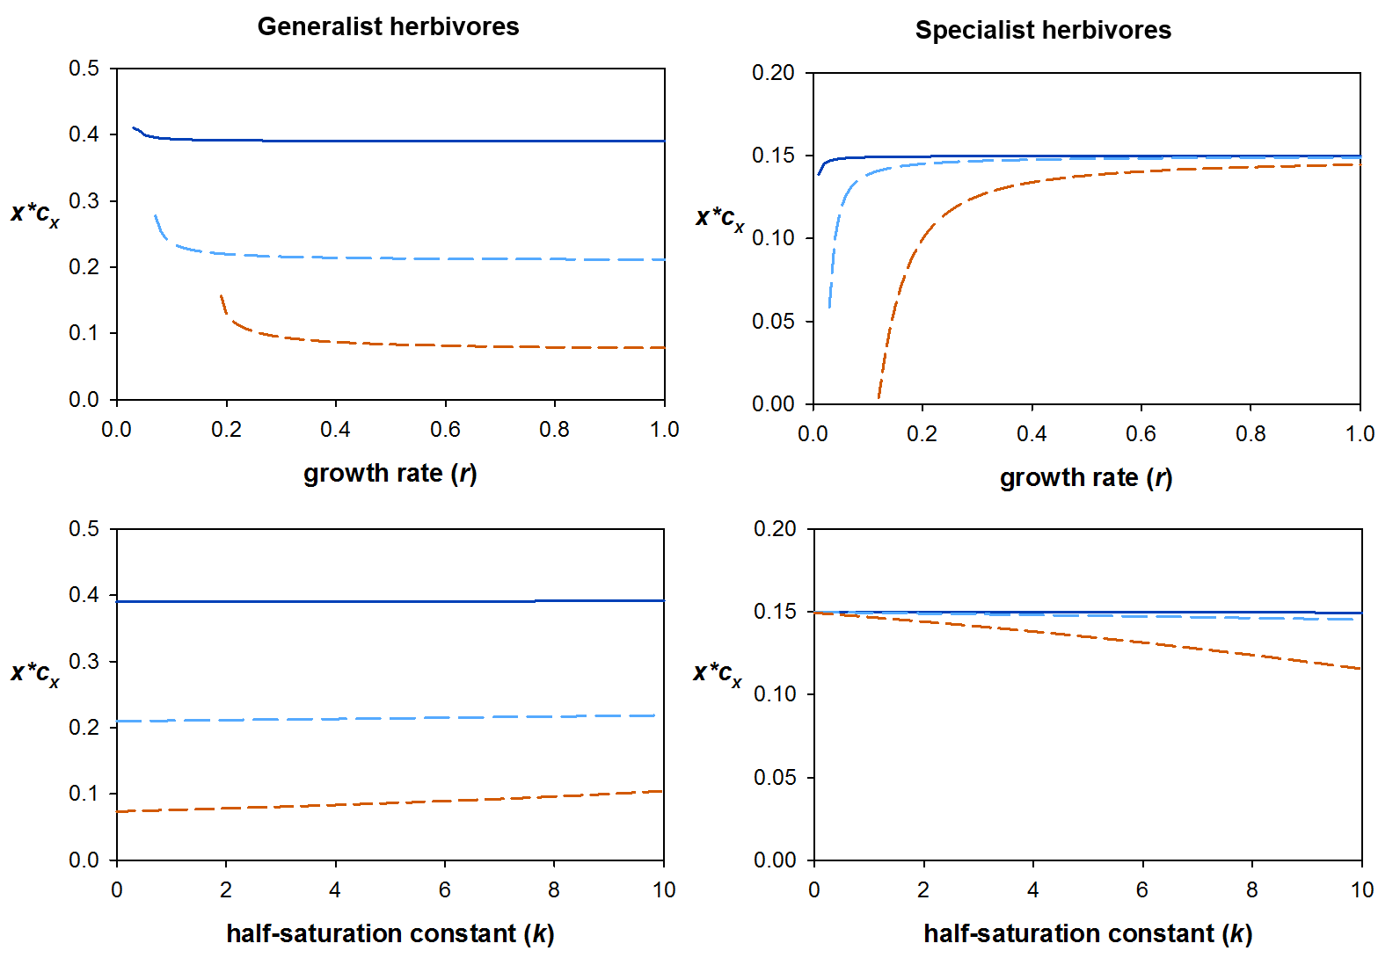
Figure A1. Numerical predictions for ESS investment depending on intrinsic growth rate (r, top panels) and the half-saturation constant for nutrient uptake (k, bottom panels) in the nutrient competition model with generalist herbivores (left) or specialist herbivores (right). Solid line: d_{p} = 0.001; long dash: d_{p} = 0.01; short dash: d_{p} = 0.05. Other parameters: , , a = 10⁻⁵, t_{h} = 0.1, T = 4∙10⁶. Top panels: k = 4∙10⁶; bottom panels: r = 0.5. Generalist herbivores (left): H = 10000; specialist herbivores (right): = 0.4, ε = 0.25, = 1.0, = 2.0.

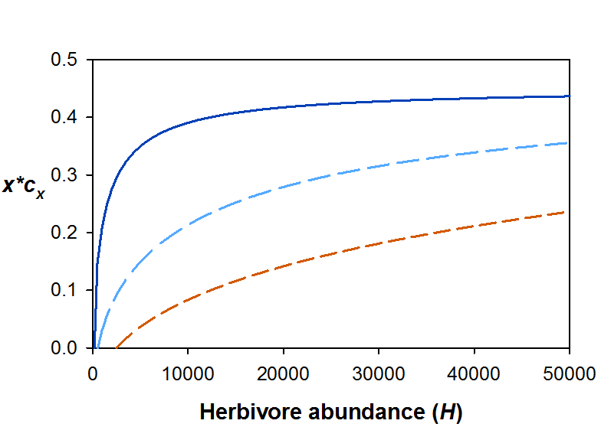
Figure A2. Numerical predictions for ESS investment depending on herbivore pressure, H, in the nutrient competition model with generalist herbivores. Solid line: d_{p} = 0.001; long dash: d_{p} = 0.01; short dash: d_{p} = 0.05. Other parameters: , , r = 0.5, a = 10⁻⁵, t_{h} = 0.1, T = k = 4∙10⁶.

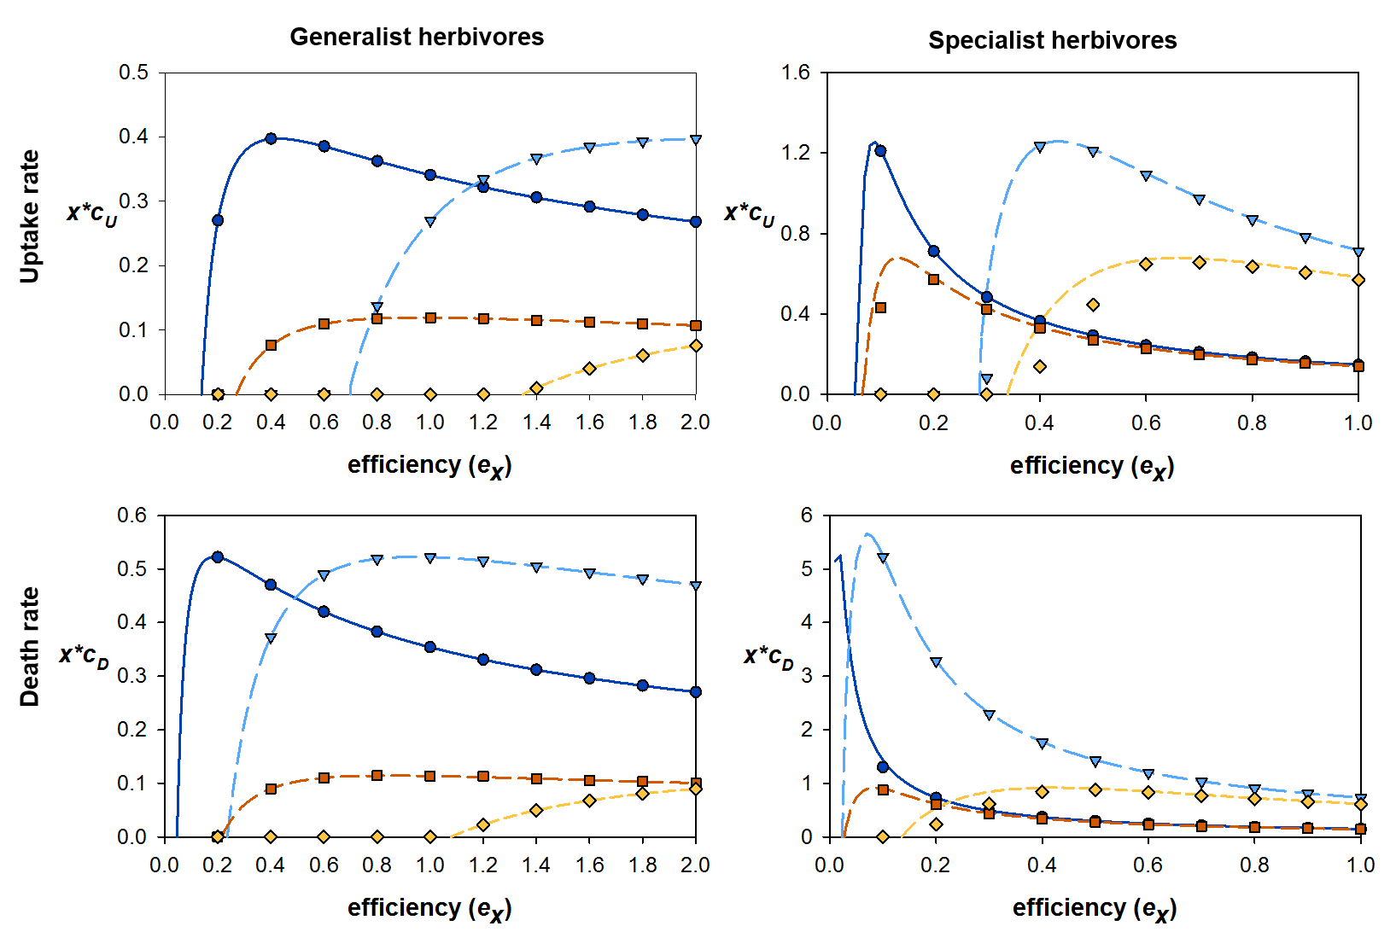
Figure A3. Numerical predictions (lines) and simulation results (symbols) for the different direct trade-offs in the nutrient competition model. Top panels: trade-off with resource uptake rate, 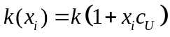; bottom panels: trade-off with death rate, 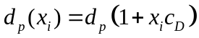. Solid line, circles: 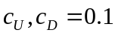, d_{p} = 0.01; long dash, triangles: 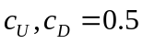, d_{p} = 0.01; medium dash, squares: , d_{p} = 0.05; short dash, diamonds: , d_{p} = 0.05. In all panels, 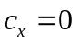, , a = 10⁻⁵, t_{h} = 0.1, k = T = 4∙10⁶, r = 0.5. Generalist herbivores (left): H = 10000; specialist herbivores (right): = 0.4, ε = 0.25, = 1.0, = 2.0.

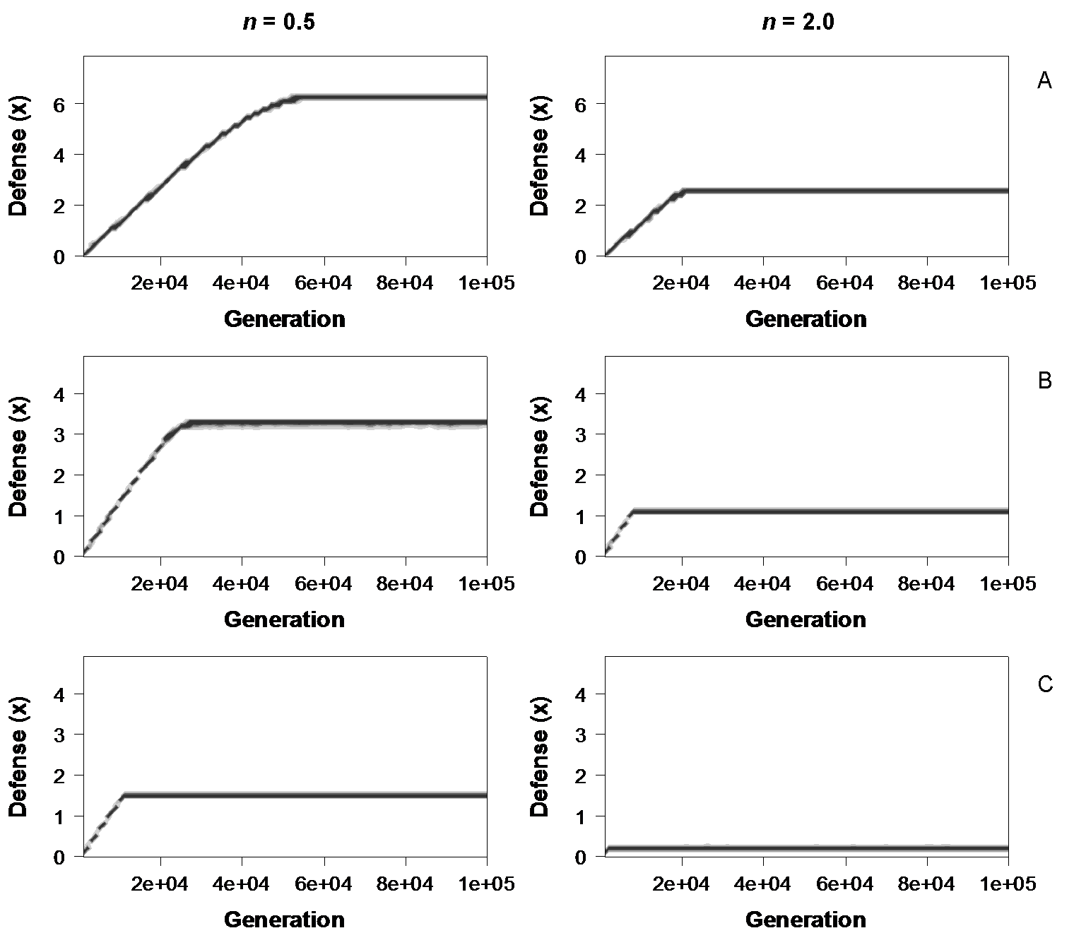
Figure A4. Examples of simulation runs for a nonlinear trade-off with growth rate, 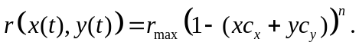 Accelerating costs are present for n < 1, while n > 1 yields decelerating costs. A: Logistic growth, K = 4∙10⁶; B: Nutrient limited growth, T = 4∙10⁶, d_{p} = 0.01; C: Nutrient limited growth, T = 4∙10⁶, d_{p} = 0.05. All graphs assume generalist herbivores, H = 10000, r = 0.5, a = 10⁻⁵, t_{h} = 0.1, , .

Appendix B: a model with non-zero mutant biomass
To construct a model with a trade-off between investment and competitiveness, we need a model definition without the assumption that the mutant biomass is zero. In this version we assume Lotka-Volterra competition, where is the intraspecific competition coefficient, and the interspecific coefficients for the resident and the mutant, 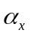 and 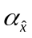, depend on the trait values and , respectively:
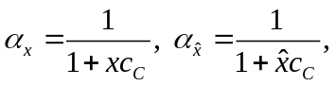
where 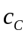 is the costliness of defense to competitiveness. We need to first define what the terms “intraspecific” and “interspecific” exactly refer to. For the purpose of this model, we define “intraspecific” as the effect that the specific subset of the population (e.g. clonal unit) has on itself, and “interspecific” as the competition with all others. So the resident’s competition coefficient denotes not only its competitive ability against the mutant, but also other residents. We further assume that the population is subdivided into a number of such subsets or units, which is similar to the way the simulations are set up (population subdivided into 200 lineages), so that the “mutant” has the biomass of one such unit, which we define as 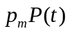.
From this we can derive the competition faced by the mutant and the residents. The mutant faces intraspecific competition from itself and interspecific competition from all the residents:
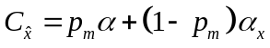
The resident faces intraspecific competition from itself, and interspecific competition from both the mutant and the other residents:
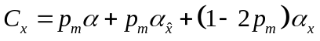
Because we want to keep the average competition at 1 (keeping the carrying capacity independent of the competition coefficients), both are divided by the average competition:
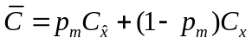
Since the competition coefficients average out, the ecological dynamics for plant biomass then look like this:
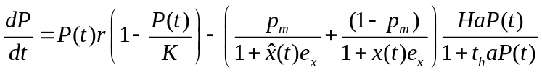
In the case of specialist herbivores, the herbivore dynamics change in the same way:

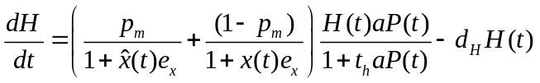
The fitness function for the mutant can be derived from the above:
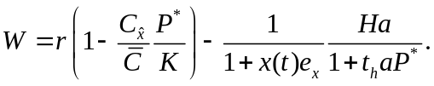
Just like in a standard invasion analysis, if W > 0, the mutant has a higher fitness than the resident and can invade; the ESS values and stability are calculated in the same way as well. We analyzed this numerically, using a value of 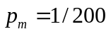 to compare the results with the simulations that have 200 lineages. The results are shown in Figure 3.

